FOLLOW-UP

Parish Stewardship Commitment Forms
The follow-up phase to the Stewardship Invitation Month is a very important component. You have now received the Parish Stewardship Commitment Forms from your parishioners and there are several steps that need to be taken.
Commitment Forms
- Separate the Commitment Forms into Time, Talent and Treasure.
Time Commitment Forms
- These forms only need to be entered into the ParishSoft database if it affects the parish, e.g. Adoration.
- If it does not, this form can be returned back to the parishioner with the Pastor’s thank you letter. A parishioner may want to place the form in an area of their home to remind them of their commitment.
Talent Commitment Forms
- The Talent Forms are to be entered into the ParishSoft database in the Ministry Scheduler Module. Instructions for this module are included in Chapter 8 of this manual.
- A report is then generated of the volunteers and should be given to the appropriate ministry leaders.
- As soon as the ministry leaders have received their lists of continuing and new volunteers, they should contact the parishioners, thank them for their stewardship gift and invite them to the next meeting of their ministry.
- If a ministry is unable to accept additional volunteers, the commitment form should be given to a ministry who does have a need for help. Every effort should be made to find a well-matched ministry.
Treasure Commitment Forms
- The Treasure Forms are turned over to the appropriate person as designated by the pastor: the Finance Council Chair, the parish bookkeeper or the staff member responsible for recording parishioner financial commitments.
- A summary of the commitments should be prepared for the pastor, Parish Stewardship Council and the Finance Council as appropriate.

Acknowledge Time, Talent, and Treasure Commitment Forms
- Thank you letters should be sent from the pastor acknowledging those who responded.
- It is important to send the thank you letters before the end of the calendar year to ensure that commitments are not forgotten.
- Example of a thank you letter is included in this chapter.
No Response Contact
- It is necessary to follow up with those who have not responded, as well as those who join the parish later in the year.
- A follow-up letter is included in this chapter.
- Stewardship materials and an invitation to make a stewardship commitment should be included in a “welcome packet” for new parishioners.

Thank You Letter to Those Who Responded

{Date}
{Family Name}
{Address}
{City, State Zip}
Dear {Parishioner}:
{Parish} has been truly blessed with a community who has accepted the invitation to Christian stewardship as a way of life as Disciples of Christ. Thank you for reflecting on your own life with our Lord and for returning your Stewardship Commitment Forms.
I am very grateful that you have committed to spending time in {prayer and quality time with your family}. I sincerely thank you for the commitment you have made to share your God-given gifts of time and talent to the following ministries and activities at {Parish}: {Ministry and Service}.
I also thank you for your commitment to give back to God through the offertory collection in the amount of {dollar amount or percentage} for the {Year} calendar year.
Your stewardship commitment of time talent and treasure will help us to preserve and expand our work in spreading the Good News. May God continue to bless you in the days to come and may the joy of giving be yours.
Sincerely yours in Christ,

Reverend {Name}
Pastor

As each one has received a gift, use it to serve one another as good stewards of God’s varied grace.
1 Peter 4:10
Follow-up Letter to Those Who Have Not Responded

{Date}
{Family Name}
{Address}
{City, State Zip}
Dear {Parishioner}:
Recently, {Parish} has been discussing Christian stewardship and our need to enter into a more prayerful life, to spend more time with our families, to share our time and talent with our parish and community, and to give a portion of our financial blessings back to God. The response to this invitation has been very inspiring. More than {number} individuals and families have made a commitment to live a life of stewardship.
The invitation to Christian stewardship is very important to our parish family. I want to be sure that everyone has an opportunity to take part in the process of deepening our relationship with the Lord. We have not yet received your response and would very much like to invite you to participate in our parish stewardship journey.
I have enclosed the Stewardship Commitment Form and Stewardship Brochure. Please take time to prayerfully consider your gift to God for the many blessings He gives you each and every day. Then mail your Commitment Forms to the parish office or drop them in the collection basket.
God has blessed us in abundant fashion. We show our gratitude by being good stewards of His abundant gifts. May God continue to bless you in the days to come and may the joy of giving be yours.
Sincerely yours in Christ,

Reverend {Name}
Pastor

As each one has received a gift, use it to serve one another as good stewards of God’s varied grace.
1 peter 4:10
Thank You Bulletin Announcements
- A sincere thank you to the many parishioners who returned their Stewardship Commitment Forms. If you have not returned your forms, it is not too late. Please drop them in the Collection Basket or mail them to the parish office this week.
- Taking good care of our parish family is like taking good care of our immediate family. We nurture and bless our parish family when we join in prayer and song at Mass, and when we offer to work in a ministry. We also help our parish family when we make a sacrifice and place our offering in the weekend offertory collection. If you have not returned your Stewardship Commitment Forms, it is not too late. Please drop them in the Collection Basket or mail them to the parish office this week.
- God has given us many gifts. I truly thank those of you who have committed yourself to being good stewards of those gifts by promising to share your time, talent, and treasure as a sign of the love and gratitude you have for Him. If you have not returned your Stewardship Commitment Forms, it is not too late. Please drop them in the Collection Basket or mail them to the parish office this week.

Annual Stewardship Report
Many parishes submit an annual report to their parishioners that is focused entirely on the financial structure of the parish. It is suggested that a Stewardship Report which includes time, talent, and treasure be submitted at the end of the year, in addition to your regular Financial Report of the Parish. The following is an example of a stewardship report.

Saint Michael Catholic Church
Salt Lake City, Utah
STEWARDSHIP REPORT
824 Households | 1,934 Individuals
Under 5 years 103 | 30 - 39 289
5 – 12 years 150 | 40 – 49 145
13 – 19 149 | 50 – 59 188
20 – 29 746 | 60 and older 164
57 New Households
934 Average Sunday Mass Attendance
22 Average Weekday Mass Attendance
Sacraments Celebrated | Christian Service
32 Anointing of the Sick | 57 Ladies Guild
25 Baptisms (includes adults) | 25 People Visited by Ministers of the Sick
73 Confirmations (includes adults) | 89 Families Adopted - Christmas Program
41 Funeral Masses
15 First Communions
10 Marriages
Prayer and Worship | Council Members
46 Altar Servers | 6 Parish Council
10 Cantors, Choir | 4 Parish Stewardship Council
109 Eucharistic Ministers | 4 Finance Council
62 Lectors
64 Ushers
339 Youth Group Participants
Christian Formation and Education | Gift of Treasure
5 Adult Faith Formation | $220,580 Offertory Pledge
10 Baptismal Preparation Class | 390 Offertory Participants
29 Bible Study Participants
5 Marriage Preparation Couples
35 Religious Education Students
28 RCIA Participants

Parish Stewardship Evaluation
The effectiveness of the stewardship effort cannot be based on financial results and volunteer commitments only. Because it is spiritually based, the results will be in the hearts of those who have responded to the stewardship message. While it is difficult to see the evidence in quantitative terms, we can see it in qualitative terms, e.g., more enthusiasm, increased joy, deeper individual commitment, and increased attendance at Mass and special liturgies.
Commitments of time, talent and treasure, however, can be measured. The results should compare the number of volunteers participating from year to year, particularly with the year prior to the first stewardship effort. Offertory giving should be analyzed by looking at comparable periods in previous years.
It is important that several members of the parish leadership meet with the pastor to formally evaluate the results of the stewardship effort. This should include the Parish Stewardship Council, Parish Council, and Finance Council. The following Parish Stewardship Evaluation form is offered to serve as an example of what can be done with a year-round stewardship effort. Each parish will want to insert their own areas for evaluation depending on their community.
PARISH STEWARDSHIP EVALUATION
Rate on a scale of 1-10, with 1 being poor and 10 being superior

Effectiveness of the Parish Stewardship Council
- The Council nurtures a year-round stewardship effort _____
- The Council has a detailed annual plan _____
- The Council has detailed responsibilities on an on-going basis _____

Comments: ______________________________________________________________________
________________________________________________________________________________
________________________________________________________________________________

Stewardship Education
- Stewardship Education for Children _____
- Stewardship Education for Youth _____
- Stewardship Education for Adults _____

Comments: ______________________________________________________________________
________________________________________________________________________________
________________________________________________________________________________

Stewardship Renewal Month
- Mailings from the Pastor _____
- Educational Materials _____
- Ministry Booklet _____
- Ministry Fair _____
- Lay Witness Testimony _____
- Time, Talent and Treasure Commitment Forms _____
- On-Going Awareness Activities _____

Comments: ______________________________________________________________________
________________________________________________________________________________
________________________________________________________________________________

Commitment and Growth
- The parish shows signs of a long-term commitment to stewardship _____
- The parish shows signs of spiritual growth _____
- The parish has grown in the area of community outreach _____

Comments: ______________________________________________________________________
________________________________________________________________________________
________________________________________________________________________________

What is a Stewardship Parish?
Ten Characteristics of a Stewardship Parish in the Diocese of Salt Lake City
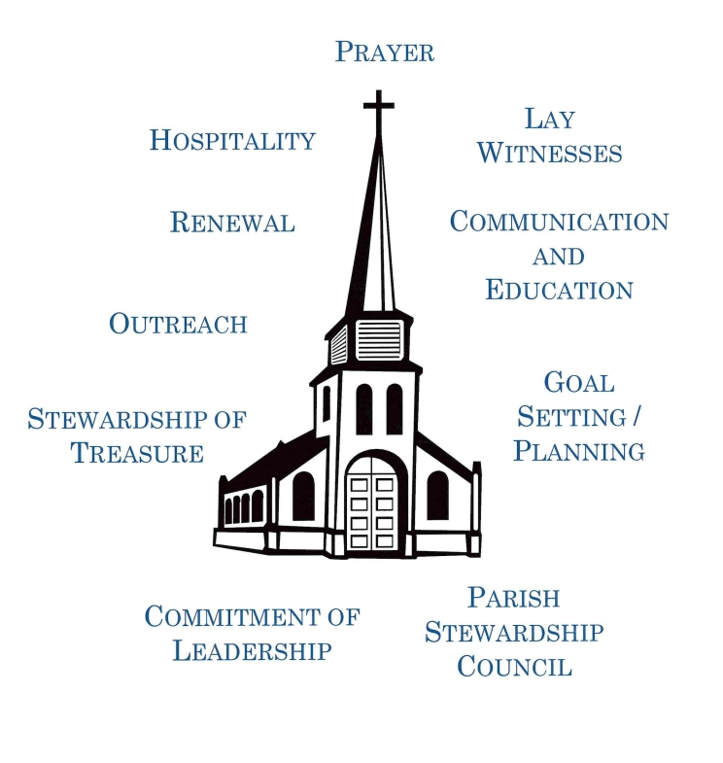

Definitions of Characteristics of a Stewardship Parish
Commitment to Leadership. It is essential for the pastor and lay leadership to express their commitment to a stewardship way of life. An environment of collaborative leadership needs to be expressed. All gifts must be valued.
Parish Stewardship Council. The Pastor creates a parish stewardship council. The council should be formed by the teachings of the Bishop’s Pastoral Letter of 1992, Stewardship: A disciple’s Response.
Prayer. The Christian steward must be rooted in the sanctifying presence of Christ through prayer that gives spiritual nourishment and a bond of unity. The parish should provide opportunities for both community and individual prayer.
Hospitality. Parishes need to warmly welcome members and visitors. Everyone has something to contribute. Everyone is needed. Communities known for their hospitality and for the depth of their service to people in need consistently inspire others to participate in ministry and to be generous in financial support.
Lay Witnesses. The personal witness of parishioner couples, families and individuals who have experienced the conversion to a stewardship way of life, is essential in building a parish foundation of stewardship.
Renewal. Stewardship is expressed not in a single process, but in a constant reminder and invitation to commit one's very self to the Lord. Annual renewals help to transform individual lives and the life of the parish.
Communication and Education. All aspects of media should be used to educate and communicate the stewardship message. This can be done through printed materials, letters, bulletins, websites, social media, videos, etc.
Outreach. The parish as a whole needs to set aside a portion of its resources to serve people in need in the parish, the diocese, and the community. The more human interaction which results from our outreach to the less fortunate, the greater God's grace is for all.
Goal Setting/Planning. Vibrant parishes have a shared vision and goals that support the vision. Goals should be set for all ministries. They should be challenging yet realistic and, when possible, measurable. Goals should be communicated clearly to the people of the parish.
Stewardship of Treasure. Within the context of theology of stewardship and ethical fundraising, leaders should not hesitate to ask for financial support of its membership. Members should reflect and give in a manner that is sacrificial, planned and proportionate to their means.

